**Live Session 07 Assignment**

**Writing functions in R**

**The live session assignment is due on Tuesday, March 07.**

Question 01

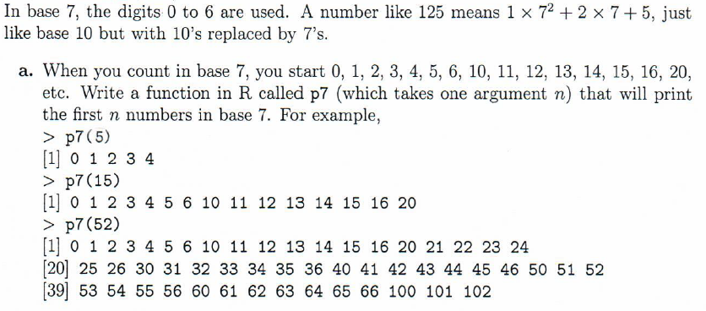

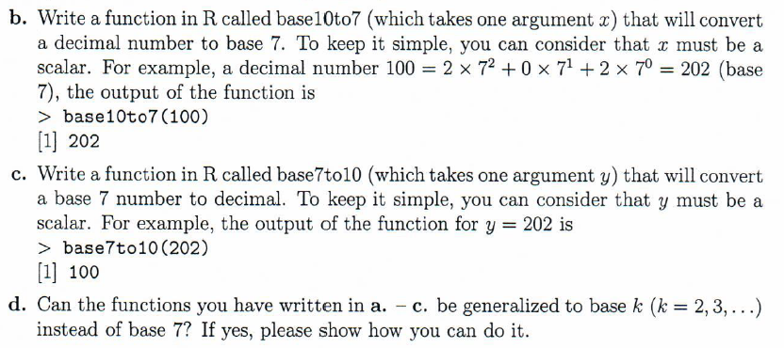

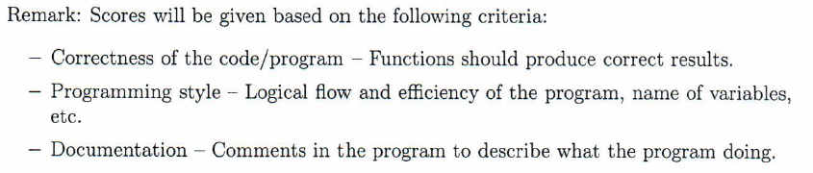

Tip: Do the part b first then do the part a and part c.

Code for part b

base10to7<-function(x){

i=0

sum=0

while(x%/%7!=0){

sum<-sum+((x%%7)*(10^i))

i=i+1

x<-x%/%7

}

sum<-sum+((x%%7)*(10^i))

return(sum)

}

base10to7(100)

Nice link to validate your base conversion code

http://www.unitconversion.org/numbers/base-7-to-base-10-conversion.html

Submit your final code as a txt file in Live session assignment 7 tab.